Course in Spirometry

Post Course Practical Submission

Student Name:
Date of Birth:
Date of face to face course attendance:
Submission Date:
Instructions

All students must submit 10 spirometry assessments conducted following your practical face to face session.
- De-identified spirometry results from a subject you have measured in the last 6 months;
  - For each trial attempted, irrespective of whether acceptability and/or repeatability criteria have been met, supply -
    - Graphical presentation of each of the trial performed – volume time and flow volume –
    - Data for all trials attempted (at least FEV1/ FVC, FVC, FEV1, PEF);
    - Comments about test acceptability and repeatability;
    - Final interpretation of results.
- Following completion please upload to the online portal as indicated or email to spirometry@kinnecttraining.com.au
  - Feedback will be provided for the submission by your Trainer / Assessor.

Please provide the following graphs / tables for each assessment by pasting a screen shot or attaching your information to this document (please make sure it is labelled correctly)
(For Easy on PC, you can show all loops by Going to main Menu - Utilities - Configuration - Test- Curve Overlay - Tick All).
To add a screen shot please use the Snipping Tool on your computer

Flow Volume Loops Graph (paste screen shot below or attach to document) | Parameters and Results (paste screen shot below or attach to document)
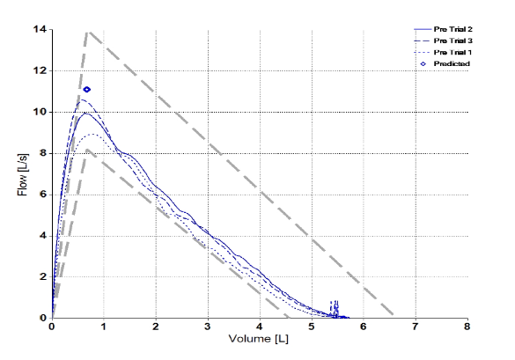 | 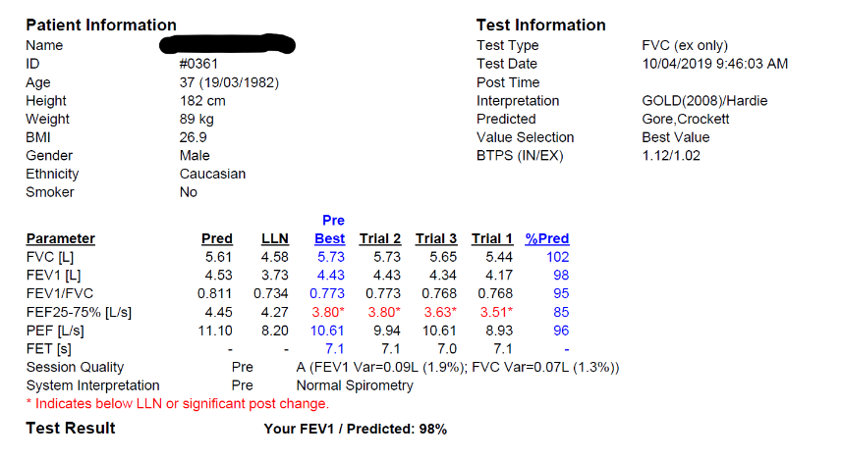
Assessment 1
Flow Volume Loops Graph (paste screen shot below or attach to document) | Parameters and Results (paste screen shot below or attach to document)

Question 1
Was a calibration check completed prior to the test?
Yes ☐ | No ☐

Question 2
Where the subject demographics entered correctly?
Yes ☐ | No ☐

Question 3
Do the following trails (1-8) meet ATS/ERS acceptability criteria?
Where trials were unacceptable, document what error(s) were identified?
Trial 1 Yes ☐ Post ☐ | No ☐  Post ☐
Trial 2 Yes ☐  Post ☐ | No ☐  Post ☐
Trial 3 Yes ☐  Post ☐ | No ☐  Post ☐
Trial 4 Yes ☐  Post ☐ | No ☐  Post ☐
Trial 5 Yes ☐  Post ☐ | No ☐  Post ☐
Trial 6 Yes ☐  Post ☐ | No ☐  Post ☐
Trial 7 Yes ☐  Post ☐ | No ☐  Post ☐
Trial 8 Yes ☐  Post ☐ | No ☐  Post ☐

Question 4
Did the subject achieve 3 technically acceptable trials?
Yes ☐ | No ☐

Question 5
Does FEV1 meet ATS/ERS repeatability criteria? What was the difference between the two largest?
Yes ☐ | No ☐

Question 6
Does FVC meet ATS/ERS repeatability criteria? What was the difference between the two largest?
Yes ☐ | No ☐

Question 7
Has an appropriate technical comment been entered on the report?
Yes ☐ | No ☐

Question 8
If not normal, select which pattern is present. Please explain your reasoning. (Restrictive, Obstructive, Mixed)

Restrictive ☐ | Obstructive ☐ | Mixed  ☐
Reasoning:

Question 9
If the pattern is obstructive, what is the severity? (Based on ATS/ERS interpretative criteria below. If your spirometer has z scores, please interpret using the z score).
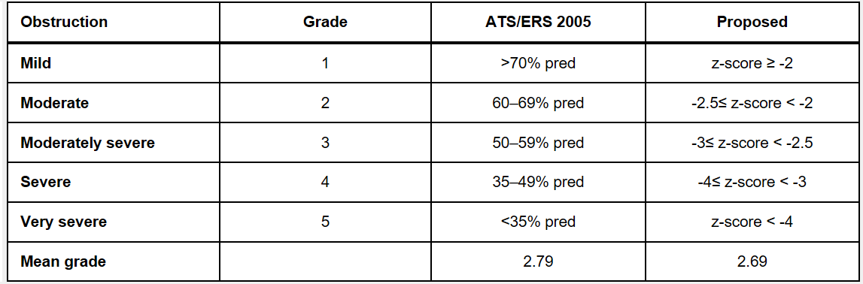
Tick the correct answer.
Mild ☐ | Moderate ☐ | Moderately Severe ☐
Severe ☐ | Very Severe ☐

Question 10
Was post-bronchodilator spirometry performed?
Yes ☐ | No ☐

Question 11  If yes, was there a significant improvement following bronchodilator? |  |  | Overall Mark:  ☐Pass  ☐Fail  ☐Needs Review
Yes ☐ | No ☐ | If Yes, a significant improvement was noted in -  FEV1 by _____________ml and ___________%  FVC by _____________ml and ___________%

Assessment 2
Flow Volume Loops Graph (paste screen shot below or attach to document) | Parameters and Results (paste screen shot below or attach to document)

Question 1
Was a calibration check completed prior to the test?
Yes ☐ | No ☐

Question 2
Where the subject demographics entered correctly?
Yes ☐ | No ☐

Question 3
Do the following trails (1-8) meet ATS/ERS acceptability criteria?
Where trials were unacceptable, document what error(s) were identified?
Trial 1 Yes ☐ Post ☐ | No ☐  Post ☐
Trial 2 Yes ☐  Post ☐ | No ☐  Post ☐
Trial 3 Yes ☐  Post ☐ | No ☐  Post ☐
Trial 4 Yes ☐  Post ☐ | No ☐  Post ☐
Trial 5 Yes ☐  Post ☐ | No ☐  Post ☐
Trial 6 Yes ☐  Post ☐ | No ☐  Post ☐
Trial 7 Yes ☐  Post ☐ | No ☐  Post ☐
Trial 8 Yes ☐  Post ☐ | No ☐  Post ☐

Question 4
Did the subject achieve 3 technically acceptable trials?
Yes ☐ | No ☐

Question 5
Does FEV1 meet ATS/ERS repeatability criteria? What was the difference between the two largest?
Yes ☐ | No ☐

Question 6
Does FVC meet ATS/ERS repeatability criteria? What was the difference between the two largest?
Yes ☐ | No ☐

Question 7
Has an appropriate technical comment been entered on the report?
Yes ☐ | No ☐

Question 8
If not normal, select which pattern is present. Please explain your reasoning. (Restrictive, Obstructive, Mixed)

Restrictive ☐ | Obstructive ☐ | Mixed  ☐
Reasoning:

Question 9
If the pattern is obstructive, what is the severity? (Based on ATS/ERS interpretative criteria below. If your spirometer has z scores, please interpret using the z score).
Tick the correct answer.
Mild ☐ | Moderate ☐ | Moderately Severe ☐
Severe ☐ | Very Severe ☐

Question 10
Was post-bronchodilator spirometry performed?
Yes ☐ | No ☐

Question 11  If yes, was there a significant improvement following bronchodilator? |  |  | Overall Mark:  ☐Pass  ☐Fail  ☐Needs Review
Yes ☐ | No ☐ | If Yes, a significant improvement was noted in -  FEV1 by _____________ml and ___________%  FVC by _____________ml and ___________%

Assessment 3
Flow Volume Loops Graph (paste screen shot below or attach to document) | Parameters and Results (paste screen shot below or attach to document)

Question 1
Was a calibration check completed prior to the test?
Yes ☐ | No ☐

Question 2
Where the subject demographics entered correctly?
Yes ☐ | No ☐

Question 3
Do the following trails (1-8) meet ATS/ERS acceptability criteria?
Where trials were unacceptable, document what error(s) were identified?
Trial 1 Yes ☐ Post ☐ | No ☐  Post ☐
Trial 2 Yes ☐  Post ☐ | No ☐  Post ☐
Trial 3 Yes ☐  Post ☐ | No ☐  Post ☐
Trial 4 Yes ☐  Post ☐ | No ☐  Post ☐
Trial 5 Yes ☐  Post ☐ | No ☐  Post ☐
Trial 6 Yes ☐  Post ☐ | No ☐  Post ☐
Trial 7 Yes ☐  Post ☐ | No ☐  Post ☐
Trial 8 Yes ☐  Post ☐ | No ☐  Post ☐

Question 4
Did the subject achieve 3 technically acceptable trials?
Yes ☐ | No ☐

Question 5
Does FEV1 meet ATS/ERS repeatability criteria? What was the difference between the two largest?
Yes ☐ | No ☐

Question 6
Does FVC meet ATS/ERS repeatability criteria? What was the difference between the two largest?
Yes ☐ | No ☐

Question 7
Has an appropriate technical comment been entered on the report?
Yes ☐ | No ☐

Question 8
If not normal, select which pattern is present. Please explain your reasoning. (Restrictive, Obstructive, Mixed)

Restrictive ☐ | Obstructive ☐ | Mixed  ☐
Reasoning:

Question 9
If the pattern is obstructive, what is the severity? (Based on ATS/ERS interpretative criteria below. If your spirometer has z scores, please interpret using the z score).
Tick the correct answer.
Mild ☐ | Moderate ☐ | Moderately Severe ☐
Severe ☐ | Very Severe ☐

Question 10
Was post-bronchodilator spirometry performed?
Yes ☐ | No ☐

Question 11  If yes, was there a significant improvement following bronchodilator? |  |  | Overall Mark:  ☐Pass  ☐Fail  ☐Needs Review
Yes ☐ | No ☐ | If Yes, a significant improvement was noted in -  FEV1 by _____________ml and ___________%  FVC by _____________ml and ___________%

Assessment 4
Flow Volume Loops Graph (paste screen shot below or attach to document) | Parameters and Results (paste screen shot below or attach to document)

Question 1
Was a calibration check completed prior to the test?
Yes ☐ | No ☐

Question 2
Where the subject demographics entered correctly?
Yes ☐ | No ☐

Question 3
Do the following trails (1-8) meet ATS/ERS acceptability criteria?
Where trials were unacceptable, document what error(s) were identified?
Trial 1 Yes ☐ Post ☐ | No ☐  Post ☐
Trial 2 Yes ☐  Post ☐ | No ☐  Post ☐
Trial 3 Yes ☐  Post ☐ | No ☐  Post ☐
Trial 4 Yes ☐  Post ☐ | No ☐  Post ☐
Trial 5 Yes ☐  Post ☐ | No ☐  Post ☐
Trial 6 Yes ☐  Post ☐ | No ☐  Post ☐
Trial 7 Yes ☐  Post ☐ | No ☐  Post ☐
Trial 8 Yes ☐  Post ☐ | No ☐  Post ☐

Question 4
Did the subject achieve 3 technically acceptable trials?
Yes ☐ | No ☐

Question 5
Does FEV1 meet ATS/ERS repeatability criteria? What was the difference between the two largest?
Yes ☐ | No ☐

Question 6
Does FVC meet ATS/ERS repeatability criteria? What was the difference between the two largest?
Yes ☐ | No ☐

Question 7
Has an appropriate technical comment been entered on the report?
Yes ☐ | No ☐

Question 8
If not normal, select which pattern is present. Please explain your reasoning. (Restrictive, Obstructive, Mixed)

Restrictive ☐ | Obstructive ☐ | Mixed  ☐
Reasoning:

Question 9
If the pattern is obstructive, what is the severity? (Based on ATS/ERS interpretative criteria below. If your spirometer has z scores, please interpret using the z score).
Tick the correct answer.
Mild ☐ | Moderate ☐ | Moderately Severe ☐
Severe ☐ | Very Severe ☐

Question 10
Was post-bronchodilator spirometry performed?
Yes ☐ | No ☐

Question 11  If yes, was there a significant improvement following bronchodilator? |  |  | Overall Mark:  ☐Pass  ☐Fail  ☐Needs Review
Yes ☐ | No ☐ | If Yes, a significant improvement was noted in -  FEV1 by _____________ml and ___________%  FVC by _____________ml and ___________%

Assessment 5
Flow Volume Loops Graph (paste screen shot below or attach to document) | Parameters and Results (paste screen shot below or attach to document)

Question 1
Was a calibration check completed prior to the test?
Yes ☐ | No ☐

Question 2
Where the subject demographics entered correctly?
Yes ☐ | No ☐

Question 3
Do the following trails (1-8) meet ATS/ERS acceptability criteria?
Where trials were unacceptable, document what error(s) were identified?
Trial 1 Yes ☐ Post ☐ | No ☐  Post ☐
Trial 2 Yes ☐  Post ☐ | No ☐  Post ☐
Trial 3 Yes ☐  Post ☐ | No ☐  Post ☐
Trial 4 Yes ☐  Post ☐ | No ☐  Post ☐
Trial 5 Yes ☐  Post ☐ | No ☐  Post ☐
Trial 6 Yes ☐  Post ☐ | No ☐  Post ☐
Trial 7 Yes ☐  Post ☐ | No ☐  Post ☐
Trial 8 Yes ☐  Post ☐ | No ☐  Post ☐

Question 4
Did the subject achieve 3 technically acceptable trials?
Yes ☐ | No ☐

Question 5
Does FEV1 meet ATS/ERS repeatability criteria? What was the difference between the two largest?
Yes ☐ | No ☐

Question 6
Does FVC meet ATS/ERS repeatability criteria? What was the difference between the two largest?
Yes ☐ | No ☐

Question 7
Has an appropriate technical comment been entered on the report?
Yes ☐ | No ☐

Question 8
If not normal, select which pattern is present. Please explain your reasoning. (Restrictive, Obstructive, Mixed)

Restrictive ☐ | Obstructive ☐ | Mixed  ☐
Reasoning:

Question 9
If the pattern is obstructive, what is the severity? (Based on ATS/ERS interpretative criteria below. If your spirometer has z scores, please interpret using the z score).
Tick the correct answer.
Mild ☐ | Moderate ☐ | Moderately Severe ☐
Severe ☐ | Very Severe ☐

Question 10
Was post-bronchodilator spirometry performed?
Yes ☐ | No ☐

Question 11  If yes, was there a significant improvement following bronchodilator? |  |  | Overall Mark:  ☐Pass  ☐Fail  ☐Needs Review
Yes ☐ | No ☐ | If Yes, a significant improvement was noted in -  FEV1 by _____________ml and ___________%  FVC by _____________ml and ___________%

Assessment 6
Flow Volume Loops Graph (paste screen shot below or attach to document) | Parameters and Results (paste screen shot below or attach to document)

Question 1
Was a calibration check completed prior to the test?
Yes ☐ | No ☐

Question 2
Where the subject demographics entered correctly?
Yes ☐ | No ☐

Question 3
Do the following trails (1-8) meet ATS/ERS acceptability criteria?
Where trials were unacceptable, document what error(s) were identified?
Trial 1 Yes ☐ Post ☐ | No ☐  Post ☐
Trial 2 Yes ☐  Post ☐ | No ☐  Post ☐
Trial 3 Yes ☐  Post ☐ | No ☐  Post ☐
Trial 4 Yes ☐  Post ☐ | No ☐  Post ☐
Trial 5 Yes ☐  Post ☐ | No ☐  Post ☐
Trial 6 Yes ☐  Post ☐ | No ☐  Post ☐
Trial 7 Yes ☐  Post ☐ | No ☐  Post ☐
Trial 8 Yes ☐  Post ☐ | No ☐  Post ☐

Question 4
Did the subject achieve 3 technically acceptable trials?
Yes ☐ | No ☐

Question 5
Does FEV1 meet ATS/ERS repeatability criteria? What was the difference between the two largest?
Yes ☐ | No ☐

Question 6
Does FVC meet ATS/ERS repeatability criteria? What was the difference between the two largest?
Yes ☐ | No ☐

Question 7
Has an appropriate technical comment been entered on the report?
Yes ☐ | No ☐

Question 8
If not normal, select which pattern is present. Please explain your reasoning. (Restrictive, Obstructive, Mixed)

Restrictive ☐ | Obstructive ☐ | Mixed  ☐
Reasoning:

Question 9
If the pattern is obstructive, what is the severity? (Based on ATS/ERS interpretative criteria below. If your spirometer has z scores, please interpret using the z score).
Tick the correct answer.
Mild ☐ | Moderate ☐ | Moderately Severe ☐
Severe ☐ | Very Severe ☐

Question 10
Was post-bronchodilator spirometry performed?
Yes ☐ | No ☐

Question 11  If yes, was there a significant improvement following bronchodilator? |  |  | Overall Mark:  ☐Pass  ☐Fail  ☐Needs Review
Yes ☐ | No ☐ | If Yes, a significant improvement was noted in -  FEV1 by _____________ml and ___________%  FVC by _____________ml and ___________%

Assessment 7
Flow Volume Loops Graph (paste screen shot below or attach to document) | Parameters and Results (paste screen shot below or attach to document)

Question 1
Was a calibration check completed prior to the test?
Yes ☐ | No ☐

Question 2
Where the subject demographics entered correctly?
Yes ☐ | No ☐

Question 3
Do the following trails (1-8) meet ATS/ERS acceptability criteria?
Where trials were unacceptable, document what error(s) were identified?
Trial 1 Yes ☐ Post ☐ | No ☐  Post ☐
Trial 2 Yes ☐  Post ☐ | No ☐  Post ☐
Trial 3 Yes ☐  Post ☐ | No ☐  Post ☐
Trial 4 Yes ☐  Post ☐ | No ☐  Post ☐
Trial 5 Yes ☐  Post ☐ | No ☐  Post ☐
Trial 6 Yes ☐  Post ☐ | No ☐  Post ☐
Trial 7 Yes ☐  Post ☐ | No ☐  Post ☐
Trial 8 Yes ☐  Post ☐ | No ☐  Post ☐

Question 4
Did the subject achieve 3 technically acceptable trials?
Yes ☐ | No ☐

Question 5
Does FEV1 meet ATS/ERS repeatability criteria? What was the difference between the two largest?
Yes ☐ | No ☐

Question 6
Does FVC meet ATS/ERS repeatability criteria? What was the difference between the two largest?
Yes ☐ | No ☐

Question 7
Has an appropriate technical comment been entered on the report?
Yes ☐ | No ☐

Question 8
If not normal, select which pattern is present. Please explain your reasoning. (Restrictive, Obstructive, Mixed)

Restrictive ☐ | Obstructive ☐ | Mixed  ☐
Reasoning:

Question 9
If the pattern is obstructive, what is the severity? (Based on ATS/ERS interpretative criteria below. If your spirometer has z scores, please interpret using the z score).
Tick the correct answer.
Mild ☐ | Moderate ☐ | Moderately Severe ☐
Severe ☐ | Very Severe ☐

Question 10
Was post-bronchodilator spirometry performed?
Yes ☐ | No ☐

Question 11  If yes, was there a significant improvement following bronchodilator? |  |  | Overall Mark:  ☐Pass  ☐Fail  ☐Needs Review
Yes ☐ | No ☐ | If Yes, a significant improvement was noted in -  FEV1 by _____________ml and ___________%  FVC by _____________ml and ___________%

Assessment 8
Flow Volume Loops Graph (paste screen shot below or attach to document) | Parameters and Results (paste screen shot below or attach to document)

Question 1
Was a calibration check completed prior to the test?
Yes ☐ | No ☐

Question 2
Where the subject demographics entered correctly?
Yes ☐ | No ☐

Question 3
Do the following trails (1-8) meet ATS/ERS acceptability criteria?
Where trials were unacceptable, document what error(s) were identified?
Trial 1 Yes ☐ Post ☐ | No ☐  Post ☐
Trial 2 Yes ☐  Post ☐ | No ☐  Post ☐
Trial 3 Yes ☐  Post ☐ | No ☐  Post ☐
Trial 4 Yes ☐  Post ☐ | No ☐  Post ☐
Trial 5 Yes ☐  Post ☐ | No ☐  Post ☐
Trial 6 Yes ☐  Post ☐ | No ☐  Post ☐
Trial 7 Yes ☐  Post ☐ | No ☐  Post ☐
Trial 8 Yes ☐  Post ☐ | No ☐  Post ☐

Question 4
Did the subject achieve 3 technically acceptable trials?
Yes ☐ | No ☐

Question 5
Does FEV1 meet ATS/ERS repeatability criteria? What was the difference between the two largest?
Yes ☐ | No ☐

Question 6
Does FVC meet ATS/ERS repeatability criteria? What was the difference between the two largest?
Yes ☐ | No ☐

Question 7
Has an appropriate technical comment been entered on the report?
Yes ☐ | No ☐

Question 8
If not normal, select which pattern is present. Please explain your reasoning. (Restrictive, Obstructive, Mixed)

Restrictive ☐ | Obstructive ☐ | Mixed  ☐
Reasoning:

Question 9
If the pattern is obstructive, what is the severity? (Based on ATS/ERS interpretative criteria below. If your spirometer has z scores, please interpret using the z score).
Tick the correct answer.
Mild ☐ | Moderate ☐ | Moderately Severe ☐
Severe ☐ | Very Severe ☐

Question 10
Was post-bronchodilator spirometry performed?
Yes ☐ | No ☐

Question 11  If yes, was there a significant improvement following bronchodilator? |  |  | Overall Mark:  ☐Pass  ☐Fail  ☐Needs Review
Yes ☐ | No ☐ | If Yes, a significant improvement was noted in -  FEV1 by _____________ml and ___________%  FVC by _____________ml and ___________%

Assessment 9
Flow Volume Loops Graph (paste screen shot below or attach to document) | Parameters and Results (paste screen shot below or attach to document)

Question 1
Was a calibration check completed prior to the test?
Yes ☐ | No ☐

Question 2
Where the subject demographics entered correctly?
Yes ☐ | No ☐

Question 3
Do the following trails (1-8) meet ATS/ERS acceptability criteria?
Where trials were unacceptable, document what error(s) were identified?
Trial 1 Yes ☐ Post ☐ | No ☐  Post ☐
Trial 2 Yes ☐  Post ☐ | No ☐  Post ☐
Trial 3 Yes ☐  Post ☐ | No ☐  Post ☐
Trial 4 Yes ☐  Post ☐ | No ☐  Post ☐
Trial 5 Yes ☐  Post ☐ | No ☐  Post ☐
Trial 6 Yes ☐  Post ☐ | No ☐  Post ☐
Trial 7 Yes ☐  Post ☐ | No ☐  Post ☐
Trial 8 Yes ☐  Post ☐ | No ☐  Post ☐

Question 4
Did the subject achieve 3 technically acceptable trials?
Yes ☐ | No ☐

Question 5
Does FEV1 meet ATS/ERS repeatability criteria? What was the difference between the two largest?
Yes ☐ | No ☐

Question 6
Does FVC meet ATS/ERS repeatability criteria? What was the difference between the two largest?
Yes ☐ | No ☐

Question 7
Has an appropriate technical comment been entered on the report?
Yes ☐ | No ☐

Question 8
If not normal, select which pattern is present. Please explain your reasoning. (Restrictive, Obstructive, Mixed)

Restrictive ☐ | Obstructive ☐ | Mixed  ☐
Reasoning:

Question 9
If the pattern is obstructive, what is the severity? (Based on ATS/ERS interpretative criteria below. If your spirometer has z scores, please interpret using the z score).
Tick the correct answer.
Mild ☐ | Moderate ☐ | Moderately Severe ☐
Severe ☐ | Very Severe ☐

Question 10
Was post-bronchodilator spirometry performed?
Yes ☐ | No ☐

Question 11  If yes, was there a significant improvement following bronchodilator? |  |  | Overall Mark:  ☐Pass  ☐Fail  ☐Needs Review
Yes ☐ | No ☐ | If Yes, a significant improvement was noted in -  FEV1 by _____________ml and ___________%  FVC by _____________ml and ___________%

Assessment 10
Flow Volume Loops Graph (paste screen shot below or attach to document) | Parameters and Results (paste screen shot below or attach to document)

Question 1
Was a calibration check completed prior to the test?
Yes ☐ | No ☐

Question 2
Where the subject demographics entered correctly?
Yes ☐ | No ☐

Question 3
Do the following trails (1-8) meet ATS/ERS acceptability criteria?
Where trials were unacceptable, document what error(s) were identified?
Trial 1 Yes ☐ Post ☐ | No ☐  Post ☐
Trial 2 Yes ☐  Post ☐ | No ☐  Post ☐
Trial 3 Yes ☐  Post ☐ | No ☐  Post ☐
Trial 4 Yes ☐  Post ☐ | No ☐  Post ☐
Trial 5 Yes ☐  Post ☐ | No ☐  Post ☐
Trial 6 Yes ☐  Post ☐ | No ☐  Post ☐
Trial 7 Yes ☐  Post ☐ | No ☐  Post ☐
Trial 8 Yes ☐  Post ☐ | No ☐  Post ☐

Question 4
Did the subject achieve 3 technically acceptable trials?
Yes ☐ | No ☐

Question 5
Does FEV1 meet ATS/ERS repeatability criteria? What was the difference between the two largest?
Yes ☐ | No ☐

Question 6
Does FVC meet ATS/ERS repeatability criteria? What was the difference between the two largest?
Yes ☐ | No ☐

Question 7
Has an appropriate technical comment been entered on the report?
Yes ☐ | No ☐

Question 8
If not normal, select which pattern is present. Please explain your reasoning. (Restrictive, Obstructive, Mixed)

Restrictive ☐ | Obstructive ☐ | Mixed  ☐
Reasoning:

Question 9
If the pattern is obstructive, what is the severity? (Based on ATS/ERS interpretative criteria below. If your spirometer has z scores, please interpret using the z score).
Tick the correct answer.
Mild ☐ | Moderate ☐ | Moderately Severe ☐
Severe ☐ | Very Severe ☐

Question 10
Was post-bronchodilator spirometry performed?
Yes ☐ | No ☐

Question 11  If yes, was there a significant improvement following bronchodilator? |  |  | Overall Mark:  ☐Pass  ☐Fail  ☐Needs Review
Yes ☐ | No ☐ | If Yes, a significant improvement was noted in -  FEV1 by _____________ml and ___________%  FVC by _____________ml and ___________%

