Course in Spirometry
Case Study – GLI Interpretation

Name
Email Address
Instructions
To ensure you have a good understanding of the pre-test requirements, please answer the following pre-test requirement questions.
Please then review the following lung function report and answer the following questions in your own words.
This case study will be reviewed in the face to face class / laboratory practical session as a group. Please be ready to discuss your responses within the group.

Pre -test requirements

- Please list the equipment requirements for your test
- How would you have ensured that your equipment is functioning properly prior to commencing the test?
- What other measures are taken prior to commencing spirometry?

The Case Study

Roger (57 years) has just been released from prison. He is coming to see you because he is short of breath walking up and down the local beach. He wonders if he has lost fitness during his time in prison.

Below you have been provided with the Guideline for Spirometry Interpretation (GLI algorithm) and the spirometry assessment data. You are required to comment on the below questions in the table provided.

- What type of defect is represented in the report?
- Can you comment on the technical comments made? Will this make any difference to his result?
- Can you classify the disease defect using the following guideline?
- What other test would have been useful in this case?

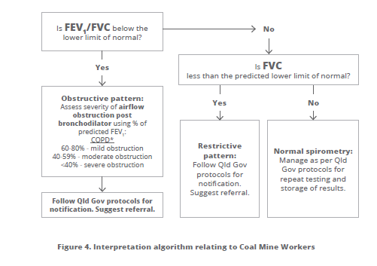

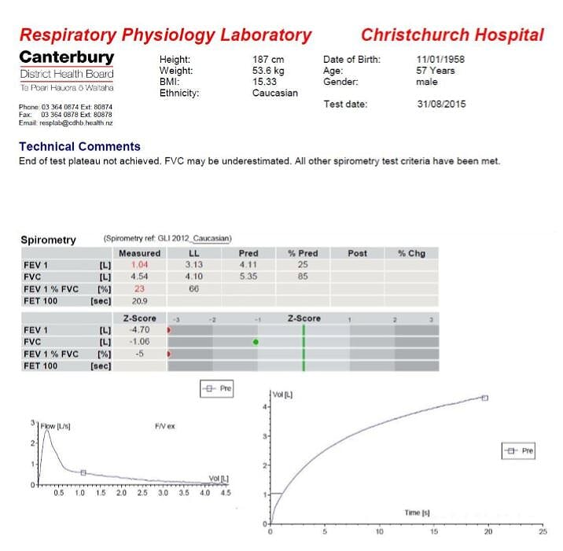

PRE-TEST REQUIREMENTS
Please list the equipment requirements for your test
How would you have ensured that your equipment is functioning properly prior to commencing the course?
What other measures are taken prior to commencing spirometry?
CASE STUDY INTERPRETATION
What type of defect is represented in the report?
Can you comment on the technical comments made? Will this make any difference to his result?
Can you classify the disease defect using the following guideline
What other test would have been useful in this case?

